

Welcome to Class Shafai



to Class Shafai
Welcome

Dear Parents and Carers,

Welcome to Class Shafai.

The classroom teacher Miss Shafai and TA Miss Davey would like to welcome you to our fabulous new classroom.

Here is our lovely classroom:
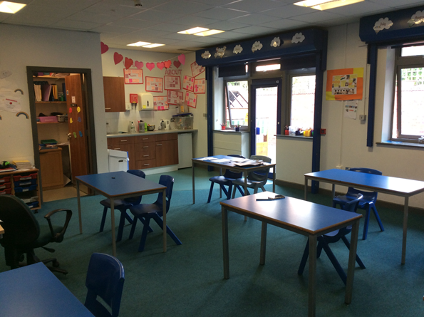


Dropping off and collecting your child from school

The school day begins at 9am. All pupils enter the school by the rear door if travelling on the school bus. If an adult is dropping off they can do this at the front of school.

Pupils finish at 3:00pm each day. Many pupils travel to and from home by taxi or mini bus provided by Trafford Transport.

If somebody different is collecting your child from school, please inform school. If the teacher does not know that somebody different will be collecting your child, they will not allow your child to leave with them.

A typical day at school

9.00am | Back doors open and children go straight in to their classes.  Reading in class.
9.30am - 10.30am | Session 1
10.30am – 11.00am | Morning playtime
11.00am – 12.00noon | Session 2
12.00pm – 1.00pm | Lunchtime: class staff sit with children
1.00pm – 1:45pm | Session 3
1.45pm – 2.30pm | Session 4
2.30pm – 3.00pm | Daily reflection & end of the day routines


Book Bags

Each child should bring a bag to school each day for reading books, letters and messages. If they do not have one they are available to buy from the school office.

Any letters or reply slips, which need to be returned, can be put in your child’s book bag. The children are encouraged to check them each morning and give things in after the register.

Any money needs to be in a clearly labelled an envelope and given in to the office or to a member of our staff team at registration.


Children are required to bring their PE kit (shorts, t-shirt and pumps/trainers) and leave it in school.

PE lessons will take place on X although there may be other times during the week when they may require their kit in school.

Please ensure that all items are clearly labelled and help us to encourage your child to take responsibility for their kit. We would also encourage children to practice getting dressed at home to help them be changed quickly in school! 


Our Reward Systems

Parents can have a choice of Daily target sheets or Daily positivity sheets for children in class.

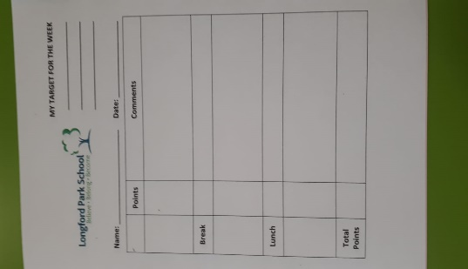

Children will earn their ‘golden time’ through making good choices in each lesson, if good choices are not made, children will talk to a staff member about ways to improve or make a different choice next time. This will often be during golden times.



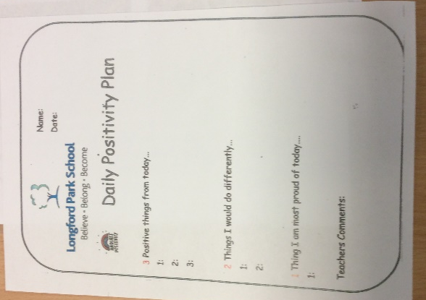
An example of a pupil daily target sheet.

An example of Daily Positivity sheets.

:

Children can earn up to 25 points in a day with a target of 23 for a good day. 5 points can be earnt for each good session.

Daily positivity sheets will include 3 positives of the day and 2 improvements for your child, as well as a note from the teacher.


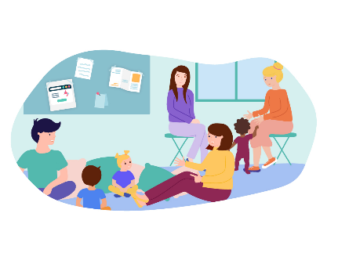





Class Dojo is our school messaging service. It is a great way to communicate with the class teacher.

We can send you messages, updates, photos and information using this service and vice versa.

We love to hear about the things you do at home. Please feel free to send us pictures or messages about things you would like to share.

Every day - Your child will be given a reading book to read at home with an adult. Please sign the reading record and then return both to school the next day. Please make the time to read with your child and encourage them to discuss the text as well as the illustrations. In line with school policy, if the book & record are not returned, a letter requesting £5 to replace the books will be sent home.

Parent Coffee mornings

The Parent Coffee mornings are an opportunity for parents to
get together and chat over coffee. It meets half-termly and is
a discussion forum without members of staff.
Everyone is welcome!

LPS Parent Partnership

We meet termly to discuss ways forward to improve and enhance the communications between home and school. It is not a mechanism for dealing with complaints of any description but will discuss/debate general issues that affect the welfare and safety of all children.



The terms are always a busy so please refer to the Calendar on the website, and be on the lookout for letters informing you of events taking place. Information is posted on the website as well letters being sent home. There are also two school information boards on the school premises; one at the front near the entrance and one at the rear of the school, near the pickup point for parents.

We are confident that your child will have a happy, productive term but should you wish to discuss any aspects of their experiences at Longford Park School, please do not hesitate to phone and discuss them with us or make an appointment through the School Office.
0161 532 3253.
Many thanks for your continued support. We look forward to working with you throughout the year.
Miss Shafai and Miss Davey

