
Class Plan
Class: Flannigan Term: Autumn 2 2022
Our big question is; What happens when it’s dark?
SUBJECT | LEARNING
LITERACY  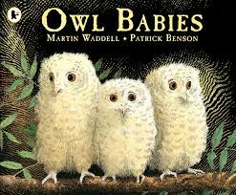  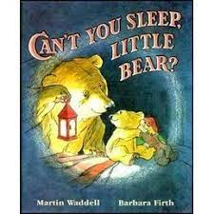  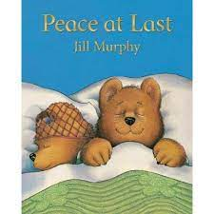 | This half term we will be continuing to develop our learning surrounding Concepts About Print (CAP). We will also be learning reading strategies such as ‘trapping’ words to aid us with our future reading skills.  Owl Babies – We will introduce the story, we will create a story map, make speech bubbles depicting what we think the owls would be saying if they were to speak and we will order the story in our books. We will be having a special visit from some owls and other birds of prey to help us with our learning. We will be linking our learning to other subjects such as science by learning that owls are nocturnal and what that means.  We will learn about other nocturnal animals by listening to the stories of; Can’t you sleep little bear and ‘peace at last’ which are both firm favourite of Mrs Flannigan
MATHS  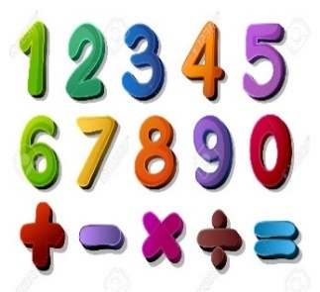 | We will be looking at;  Mass – exploring weights and introducing the language of heavy and light  Capacity – full, half full, empty  2d shapes – names and properties (circles and triangles)  Repeating patterns  Revising composition of numbers to 3 including subitising  Positional Language
SCIENCE | Nocturnal and diurnal  Hibernation  Sources of light  The best materials for reflecting light (linking to road safety)  The best materials to block light  Touching on habitats – linking to nocturnal/hibernating animals
History  Geography | History  Compare similarities and differences between families  Poppy Day – 11th November | Geography  We will begin our weekly ‘where in the world?’ sessions  Week 1 – India (Linking to Diwali)  Week 2 – London (linking to Guy Fawkes and bonfire night)  Week 3 – Manchester (Linking to our local environment)  Week 4 – Ireland (Learning about the four nations) Week 5 – Wales (Learning about the four nations)  Week 6 – Edinburgh (Linking to Hogmanay)  RE – Visit to St Hilda’s (Linking to Christian celebration of Christmas)  Hannukah  Music - Trafford Music Service on a Thursday.  Computing – Positional Language  PE – taught by Mr Ritchie on a Wednesday – Please have PE kits in school.
SPECIAL EVENTS/HOLIDAYS   | Please keep up-to-date with letters and our web page where you find all our special events organised!  - Please refer to our school calendar 2022-2023 – reminders to follow as and when they occur.
READING   | We read every day in school.  Books will be sent home each Friday with children. Please complete their Reading record with a brief comment about anything that they enjoyed/found difficult/easy. Books are to be returned on a Friday please so that we can swap it for a new one

