
Class Plan
Class: Lamb Term: Autumn 2 2022
SUBJECT | LEARNING
LITERACY  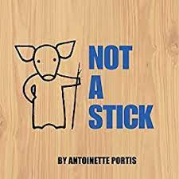 | This term we will be reading, learning and writing about:  Not a Stick  We will be writing lists and non – fiction texts.
MATHS  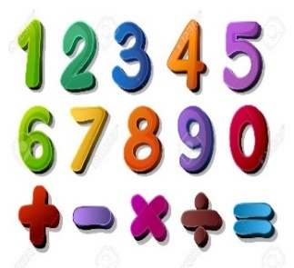 | Autumn 2  Year 1  Recall all pairs of additions and subtractions number bonds to 20.  Add and subtract 1-digit and 2-digit numbers to 20, including zero.  Money linked to addition and subtraction (3 weeks) | Autumn 1 and 2  Year 2  Add and subtract: two 1-digit; 2-digit and a 1 digit; 2-digit and 10s; two 2-digit and three 1-digit numbers.  Solve problems with addition and subtraction.  Money linked to addition and subtraction.  Times tables  Recall and use multiplication and division facts for the 2, 5 and 10x multiplication tables.
SCIENCE  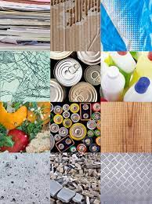 | Year 2  Use of everyday materials  Identify and compare the suitability of a variety of everyday materials, including wood, metal, plastic, glass, brick, rock, paper and cardboard for particular uses.  Find out how the shapes of solid objects made from some materials can be changed by squashing, bending, twisting and stretching.
HISTORY  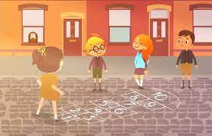 | History - Commemorating Events within Living Memory topic -  Childhood through time.  Historical Enquiry  ● Ask and answer questions  Interpreting History  ● Identify different ways that the past is represented e.g fictional accounts, illustrations, films, songs, museum displays  Continuity and Change  ● Discuss change and continuity in an aspect of life  Similarities and Differences  ● Identify similarities and differences between ways of life in different periods, including in their own lives  Art – Yayoi Kusama  Printing - copying an original print by making own simple print blocks (eg by cutting veg/pieces of card),  Sculpture - cutting/combining shapes to make recognisable forms using clay  RE – Who is a Christian and what do they believe? Christmas  Music - Trafford Music Service on a Thursday.  Computing – E Safety and programming.  DT – Cooking  PE – taught by Mr Ritchie on a Wednesday – Please have PE kits in school.
SPECIAL EVENTS/HOLIDAYS   | Please keep up-to-date with letters and our web page where you find all our special events organised!  - Please refer to our school calendar 2022-2023 – reminders to follow as and when they occur.
READING   | We read every day in school.  Your child will taking a reading book home to read with an adult. Please try and read a few pages with your child and record it in their reading record.

