
Class Plans
CLASS: Patel Term: Autumn Term 2
SUBJECT | LEARNING
LITERACY  The Girl Who Stole an Elephant by Nizrana Farook | The Girl Who Stole an Elephant  This term we will be exploring this exciting adventure story, examining characterisation and descriptive language. Learn how to integrate dialogue and to use expanded noun phrases. Improvise, draft, write and perform a playscript based on the book. Establish cross-curriculur links, especially ICT as we will incorporate our information texts into some Game cases.  In conjunction, we will further strengthen our proper use of spelling, grammar and punctuation in our writing.
MATHEMATICS  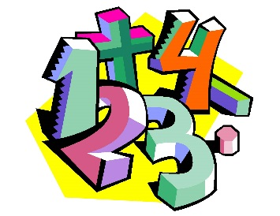 | Spring 2 – Year 5  Week 1-3 – Multiplication & Division  Week 4-7 – Fractions A | Spring 2 – Year 5  Week 1-3 – Multiplication & Division  Week 4-7 – Fractions A
Spring 2- Year 6
Week 1-2 - Fractions A
Week 3-6 Fractions B
Week 7 Fractions, decimals and percentages

SCIENCE   | Year 5 – Properties & Changes of Materials  - Food Prep Materials Challenge  - Keeping it Hot, Keeping it Cold  - Food Packaging  - Cleaning Team  - Electrical Health and Safety  - Keeping the Sound Contained | Year 6 – Evolution And Inheritance  - Inheritance Detective  - Mutations and Adaptations  - Extreme Survival  - Meet the evolutionary Pioneers  - Evolutionary trees and fossils  - The Tale of the Giraffes Neck
OTHER TOPICS | Dinosaurs and Fossils  This terms History topic is going to be learning about Dinosaurs and Fossils. We will investigate types of fossils and how we find dinosaur fossils. We hope to carry out some fieldwork into our own community to help us with our understanding of our own area.  Music - with Beth from Trafford Music Service on Thursday.  PE – ABC’s with Mr Ritchie on Thursdays. Please ensure all children have a PE to participate.
SPECIAL EVENTS/HOLIDAYS   | Please keep up-to-date with letters and our web page where you find all our special events oraganised!  - Please refer to our school calender 2022-2023 – reminders to follow as and when they occur.
HOMEWORK PRIORITIES   | There is no official homework that is set by class but please make sure to work with your child on:  - Maths: Practice times tables. All children have Times Table Rockstars logins and set times tables.  - English: Work on spellings from their reading books.  - Reading: Please read the book you take home regularly

INDIVIDUAL BEHAVIOUR TARGETS
Please refer to your child’s IBP and get in touch with the class teacher if you have any concerns.
....................................................................................................................................................

