
Class Plans
Class: Wilson/ Shafai Term: Autumn 1 2022
SUBJECT | LEARNING
LITERACY   | Poetry: This term our focus book will be focusing on Michael Rosen’s poetry. His poems are world renowned and loved by millions of people and we can not wait to learn about poems and how to write them.  We will also be concentrating on our punctuation and grammar and making our poems very interesting by using lots of adjectives, nouns, verbs and adverbs.
MATHEMATICS  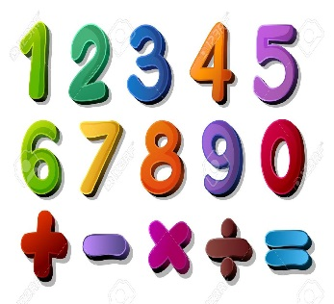 | Autumn one  Place Value: We will be learning the given value of a number.  Addition and Subtraction We will be learning how to add and subtract numbers and begin to learn the column method | Alongside our topics in Maths, we will also be focusing on our times tables once a week so that we can start to become fluent in them.
SCIENCE   | Autumn one  Living things and their habitats: We will be learning about different kinds of animals (including humans) and their life processes. We will be learning lots of scientific language such as what herbivore and carnivore means | We will think about our topic and come up with enquiry questions and find out the answers to our questions!
OTHER TOPICS    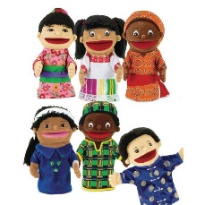 | Geography Our local environment: Manchester: We will be looking at our local area and learning all about Manchester and its place, geographically, in the world. We will also be learning lots of new geography words  DT: This term we will be focussing on puppets. We will be looking at how to stich our puppets and designing our own puppets  RE – We are looking into what God means to different people and how Jesus is important to people too  French- Every Tuesday with our teacher who comes from France  Music - with Trafford Music Service on Thursday.  PE – with Mr Ritchie on Friday .
SPECIAL EVENTS/HOLIDAYS   | Please keep up-to-date with letters and our web page where you find all our special events organised!  - Please refer to our school calendar 2022-2023 – reminders to follow as and when they occur.
READING   | We read every day in school and if possible, we would like you to read with your child each night.

INDIVIDUAL BEHAVIOUR TARGETS
Please refer to your child’s IBP and get in touch with the class teacher if you have any concerns.
...................................................................................................................................................

