
Class Plan
Class: Flannigan Term: Autumn 1 2022
Our big question is; What makes me marvellous?
SUBJECT | LEARNING
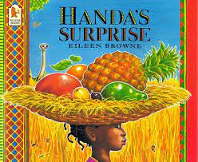  LITERACY  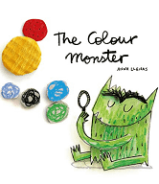  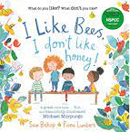  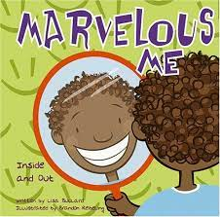 | This half term we will be working on our Concepts About Print (CAP) whilst settling into life in reception.  We will be learning about ourselves through a range of texts.  The Colour Monster – We will read the story and learn about our zones of regulation. We will do an emotional check in each day and will design our own monsters using a range of materials in the colour that best suits our feelings.  Marvellous me – We will read the story and learn about our similarities and differences then draw pictures of our families and talk about where we live and who lives with us.  I like bees, I don’t like honey – We will read the story and draw pictures of things we like and dislike and talk about why  Handa’s Surprise – We will read the story and talk about our favourite fruits. We will taste our own fruits and draw a picture of our favourite. We will use the story to talk about characters and will choose our favourite character from the story then make marks in our book to show this.
MATHS  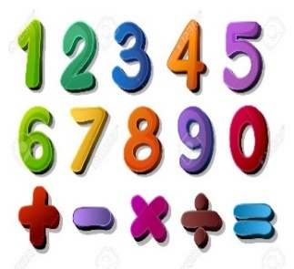 | We will be looking at the composition of numbers within 5 in a variety of ways.  We will be; matching, sorting and comparing amounts  We will be beginning to learn about different measurements such as height.  Comparing amounts – more and fewer
SCIENCE  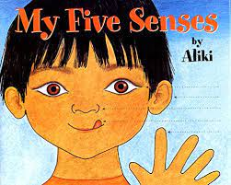 | We will be learning the names of our body parts and labelling our own bodies.  We will talk about healthy and unhealthy food and will complete sorting activities.  We will learn about the importance of looking after our teeth and washing our hands to keep germs away.  We will read the story of ‘my five senses’ and will conduct a range of experiments to explore this. We will have sound pots and will make predictions about what is inside each one using our ears.  We will have feely bags and will use a range of vocabulary to describe what we can feel and what we think we are touching with our hands.  We will use our tongues to taste a range of different foods that are one of the four; sweet, salty, sour or bitter.  We will play ‘Kim’s game’ to test our sense of sight and our memory.
GEOGRAPHY  History   | Recycling – Our local environment  Looking at local landmarks  Creating maps  RE – Learning about ourselves and what our interests are  Rosh Hashana  Diwali  Music - Trafford Music Service on a Thursday.  Computing – Positional Language  PE – taught by Mr Ritchie on a Wednesday – Please have PE kits in school.
SPECIAL EVENTS/HOLIDAYS   | Please keep up-to-date with letters and our web page where you find all our special events organised!  - Please refer to our school calendar 2022-2023 – reminders to follow as and when they occur.
READING  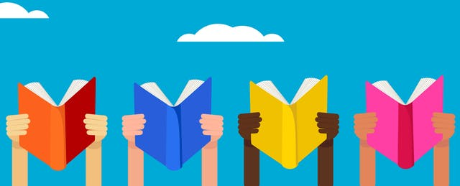 | We read every day in school.  We will begin to send books home each Friday beginning in Autumn 2 when we have completed our settling in period and our baseline assessments.

