
Class Plan
Class: Lamb Term: Autumn 1 2022
SUBJECT | LEARNING
LITERACY  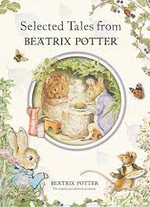 | This term we will be reading, learning and writing about:  A House That Once Was by Julie Fogliano and Lane Smith.  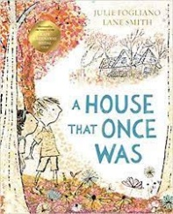  Beatrix Potter  The Tale of Two Bad Mice, The Tale of Tom Kitten and other books written by Beatrix Potter.
MATHS  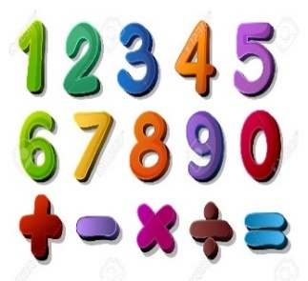 | Autumn 1 and 2  Year 1  Place Value (4 weeks)  Addition and Subtraction (4 weeks)  Money linked to addition and subtraction (3 weeks) | Autumn 1 and 2  Year 2  Place Value (4 weeks)  Addition and Subtraction (4 weeks)  Money linked to addition and subtraction (3 weeks)
SCIENCE  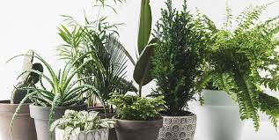 | Year 1 and Year 2  Plants  To identify and name a variety of common wild and garden plants, including deciduous and evergreen trees.  To identify and describe the basic structure of a variety of common flowering plants, including trees.
GEOGRAPHY   | Recycling - Where does our rubbish go?  RE – Who is a Christian and what do they believe?  Music - Trafford Music Service on a Thursday.  Computing – E Safety and programming.  PE – taught by Mr Ritchie on a Wednesday – Please have PE kits in school.
SPECIAL EVENTS/HOLIDAYS   | Please keep up-to-date with letters and our web page where you find all our special events organised!  - Please refer to our school calendar 2022-2023 – reminders to follow as and when they occur.
READING   | We read every day in school.  Your child will taking a reading book home to read with an adult. Please try and read a few pages with your child and record it in their reading record.

