
Class Plans
CLASS: Pearce Term: Autumn Term 1
SUBJECT | LEARNING
LITERACY  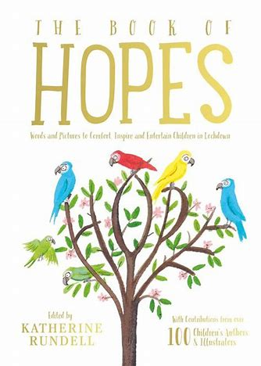 | The Book of Hopes  This term we will be exploring Poetry. The Book of Hopes was written during the coronavirus pandemic and all of its proceeds went towards the NHS. We will explore a selection of poems discussing the theme of Hope. The module will conclude after exploring grammar features within poetry with the children creating their own stories on Hope which we will collate into our own class book.  After our poetry module we will move onto fiction and explore the story, The Girl Who Stole an Elephant.
MATHEMATICS   | Autumn 2 Year five  Unit 1 – Place Value and negative numbers  Unit 2 – addition and subtraction | Autumn 2 Year 6  Unit 1 – Place Value  Unit 2 – Addition, Subtraction, Multiplication and Division
Times Tables
Tames tables lessons take place once each week. We focus on filling any gaps children may have through a variety of fun and engaging activities.
SCIENCE | Living things and their habitats  - Classifying animals  - The Linnean system  - Animal characteristics  - Helpful and harmful microorganisms  - Mould investigation  - Finding organisms in my local habitat
OTHER TOPICS | Geography – Water Friend or Foe. Within this module we will explore some famous rivers in the UK and around the world. We will uses atlas’s to locate these rivers, learn and identify key parts of rivers and what they are used for around the globe. The module will conclude by learning about dams and debating if overall they have a positive or negative impact on people and the environment,  Music - with Beth from Trafford Music Service on Friday.  PE – on a Thursday with Mr Ritchie, Play to Learn with Mr Roberts on a Friday  RE – Judaism and Christianity
SPECIAL EVENTS/HOLIDAYS   | Please keep up-to-date with letters and our web page where you find all our special events oraganised!  - Please refer to our school calender 2022-2023 reminders to follow as and when they occur.
HOMEWORK PRIORITIES   | There is no official homework that is set by class but please make sure to work with your child on:  - Maths: Practice times tables. All children have Times Table Rockstars logins and set times tables.  - English: Work on spellings from their reading books.  - Reading: Please read the book you take home every evening

INDIVIDUAL BEHAVIOUR TARGETS
Please refer to your child’s IEP and get in touch with the class teacher if you have any concerns.
....................................................................................................................................................

