
Class Plan
Class: Tan Term: Autumn 1 2022
SUBJECT | LEARNING
LITERACY  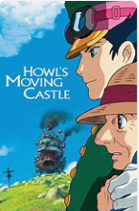 | This term we will be following the story of Howl’s Moving Castle.  We will be thinking about exciting characters, setting and plot and we will write our own adventure story. We will use the animated fantasy film written and directed by Hayao Miyazaki to support us with our understanding.
MATHS  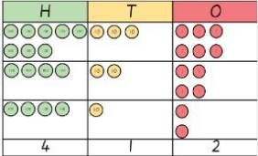 | We will start off the half term by ensuring a good understanding of number and place value. We will use various models and images to support us with our learning. These will include place value charts, place value counters and base ten.  We will use our understanding of number and place value to help us understand our addition and subtraction.
SCIENCE  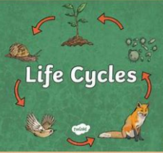 | Lifecycles  We will consider the similarities and differences between the life cycle of mammals, amphibians, insects and birds. We will look at the different ways plants reproduce and plan our own baby spider plants. We will learn about metamorphosis and discuss similarities and differences between different lifecycles.
Geography  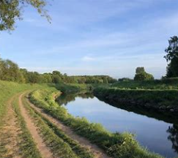 | In Geography we will follow the course of the River Mersey and learn about some of the places along the way. We will consider the impact the river has on the local population and landscape. We will also learn about the different parts of the river from it’s tributaries to the Mesrsey Estuary.  RE – Believing (Religious beliefs, teachings, sources; questions about meaning, purpose and truth)  Music - Trafford Music Service on a Thursday.  Computing – Staying Safe online  PE – taught by Mr Ritchie on a Wednesday – Please have PE kits in school.
SPECIAL EVENTS/  HOLIDAYS  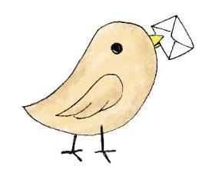 | Please keep up-to-date with letters and our web page where you find all our special events organised!  - Please refer to our school calendar 2022-2023 – reminders to follow as and when they occur.
READING   | We read every day in school.  Your child will taking a reading book home to read with an adult. Please try and read a few pages with your child and record it in their reading record.

