CLASS Broomhead January 2022- February 2022

SUBJECT | LEARNING
English – Fiction – Stories on a theme (everyday life)  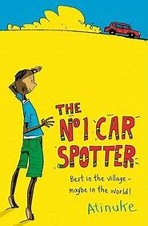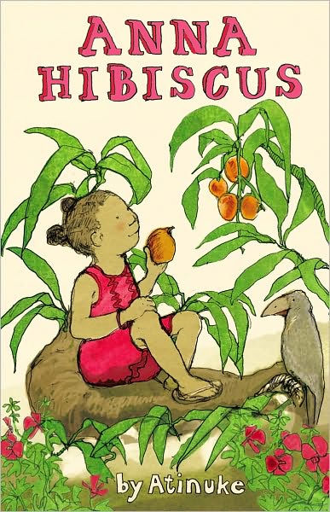 | - Summarise a text  - Compare two different texts with a similar theme  - Explore verbs and present tense  - Create a ‘realistic’ character  - Plan a  - Editing and improving writing
  NUMERACY | - Length  - Perimeter  - Area  - Fractions
SCIENCE – States of Matter (Year 4)  - Earth & Space (Year 5)  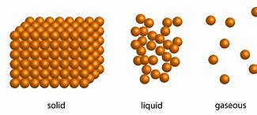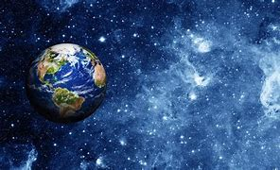 | Year 4  - Distinguish between solids, liquids and gases  - Make observations over time  - Learn about evaporation and condensation  - Understand the water cycle | Year 5  - Develop own scientific enquiry questions  - Create a model solar system  - Explain how the solar system works  - Carry out an investigation to prove that the earth spins
Geography – The Vikings in Britain  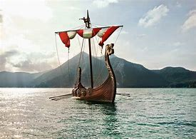 | - Discover who the Vikings were and where they came from  - What made the Viking raids successful and consider it from an Anglo-Saxon point of view.  - Researching Viking warriors  - Discover how longships were built and design and build own longship  - Were all Vikings warriors?
Other curriculum areas | Computing – Data handling  D.T – 3D maps  PSHE – Using stories to learn about others lives  R.E – Being a hindu  P.E – weekly session with Mr Ritchie  Music – Weekly session with Beth
HOMEWORK PRIORITIES | - Reading nightly  - TT Rockstars (10-15 mins)

