
Class Plan
Class: Lamb Term: Summer 2022
SUBJECT | LEARNING
LITERACY  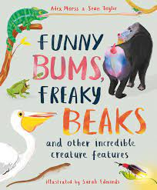 | This term we will be reading : Funny bums, freaky beaks and other incredible creature features.  Read, talk and write non – fiction texts about incredible creatures.  - Use a capital letter, full stop, question mark, exclamation mark and commas in a list.  - Use the suffixes s es ed er ing  - Use past and present tense.  - Write a non – fiction text using headings and subheadings.  - Use subordinating conjunctions and subordinate clauses conjunctions (and, if when, but, because, or)  - Phonics work and spelling  - Dictionary work – Year 3
MATHS  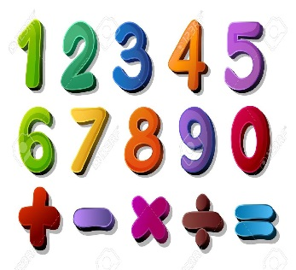 | Summer 1 and 2  Year 1 and 2  Multiplication and Division  Fractions – Name the fractions 1/3 ¼ ½ ¾  Year 3  Multiplication and Division  Angles  Count in multiples of 4, 8 50 and 100  Fractions – add and subtract with the same denominator
SCIENCE  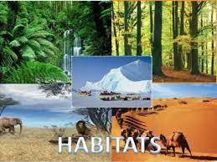  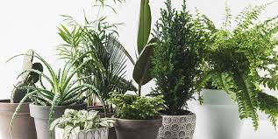 | Year 2 - Living things and their habitats  What questions do I have about this topic?  What are the differences between things that are living, dead and have never been alive?  What are habitats?  How can I map a habitat and identify what is in it?  How do I identify animals in their habitats?  How do I explain how living things in a habitat depend on each other?  Microhabitats  How do animals find their food?  Year 3 - Plants  Identify and describe the functions of different parts of flowering plants: roots, stem/trunk, leaves and flowers.  Explore the requirements of plants for life and growth (air, light, water, nutrients from soil, and room to grow) and how they vary from plant to plant.  Investigate the way in which water is transported within plants.  Explore the part that flowers play in the life cycle of flowering plants, including pollination, seed formation and seed dispersal.
Geography  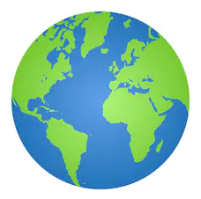  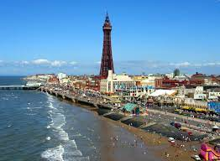 | Topic: Locational/place knowledge - Oh we do like to be beside the seaside!  Place knowledge  ▪ understand geographical similarities and differences through studying the human and physical geography of a small area of the United Kingdom, and of a small contrasting location  Human and physical geography  ▪ use basic geographical vocabulary to refer to key physical features, including: beach, cliff, coast, forest, hill, mountain, sea, ocean, river, soil, valley, vegetation, season and weather, and key human features, including: city, town, village, factory, farm, house, office, port, harbour and shop  Geographical skills and fieldwork  ▪ use simple fieldwork and observational skills to study the geography of the location and the key human and physical features of its surrounding environment.  Art – Gustav Klimt  Exploring and Developing Ideas, Work of Artists,  Textiles weaving and decorating with glued on decorations  Collage selecting different colours & using a range of materials to create effect.  RE – What does it mean to belong to a faith community?  Music - Trafford Music Service on Tuesdays.  PE – taught by Mr Ritchie on Monday – Please have your PE kit.
SPECIAL EVENTS/HOLIDAYS   | Please keep up-to-date with letters and our web page where you find all our special events organised!  - Please refer to our school calendar 2021-2022 – reminders to follow as and when they occur.  Please keep your eye on Class Dojo for class and school information. If you need to contact me please do via Dojo or call the school.
READING   | We read every day in school and if possible, we would like you to read with your child each night. Please record this in your child’s reading record.

