
Class Plans
Class: Shafai Term: Summer 1 2022
SUBJECT | LEARNING
LITERACY  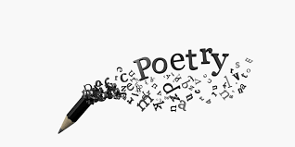 | Poetry: This term our focus book will be focusing on Michael Rosen’s poetry and Benjamin Zephaniah’s poetry. There poems are world renowned and loved by millions of people and we can not wait to learn about poems and how to write them.  We will also be concentrating on our punctuation and grammar and making our poems very interesting by using lots of adjectives, nouns, verbs and adverbs.
MATHEMATICS  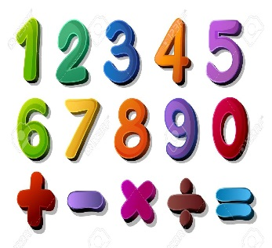 | Summer one Year Two  Fractions  Division | Summer one Year Three  Fractions  Division
SCIENCE   | Year Three- Electricity  We will be looking at electricity in depth and learning lots of new science words that relate to this topic | Year Four- Electricity  We will be looking at this in depth and learning what we use it for and why it is so important  We will all think about our topics and come up with enquiry questions and find out the answers to our questions!
OTHER TOPICS  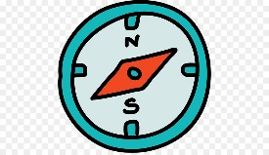  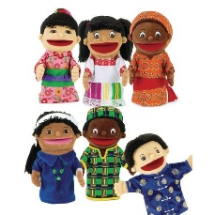 | History: Crime and Punishment: we will be looking at how the police were formed and why and what crimes from the past are no longer relevant today  Design Technology  This term we will be focussing on food packaging. We will be looking at how packaging has changed throughout the years and how we can make our own packaging.  RE – We are looking into Sikhism  French- Every Tuesday with our teacher who comes from France  Music - with Trafford Music Service on Thursday.  PE – with Mr Ritchie on Wednesdays.
SPECIAL EVENTS/HOLIDAYS   | Please keep up-to-date with letters and our web page where you find all our special events organised!  - Please refer to our school calendar 2021-2022 – reminders to follow as and when they occur.
READING   | We read every day in school and if possible, we would like you to read with your child each night.

INDIVIDUAL BEHAVIOUR TARGETS
Please refer to your child’s IBP and get in touch with the class teacher if you have any concerns.
...................................................................................................................................................

