
Class Plans
Class: Jackson Term: Summer 1 2022
SUBJECT | LEARNING
LITERACY   | Persuasive Writing:  This term we will be looking at poem ‘Bedtime’ by Eleanor Farjeon to inspire us to speak and write powerfully about bedtimes. We will be creating arguments about staying up later, create adverts for bedroom inventions and write a letter to petition for a pyjama party. We will be working hard on our spelling and grammar, including tense and sentence forms.
MATHEMATICS  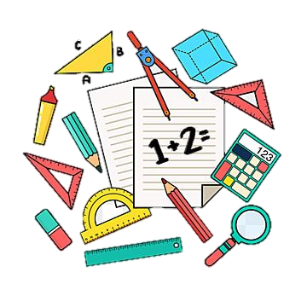 | Spring Two Year Two  Statistics  Mass, Capacity and Temperature | Spring Two Year Three  Statistics  Mass, Capacity and Temperature
SCIENCE   | Year Three- Plants  The alien beings on Planet Dock 5 need our help. They want to open a hotel for humans on their planet but they have a problem. It’s too far away to have deliveries of fresh food from Earth so they need to build a space farm for Earth food plants. The problem is, they have no idea what these plants need to grow. We are going to become their Earth Plant researchers to conduct experiments to find out what different plants need to grow. | Year Four- Electricity  We are going to learn all about electrical circuits and test materials' ability to conduct electricity. We will put our own knowledge of circuits on display by building our own circuit to create a buzz-wire game. Then, we will use our game to try to defeat a challenger. Who can remain ‘disconnected’ on the game?
OTHER TOPICS  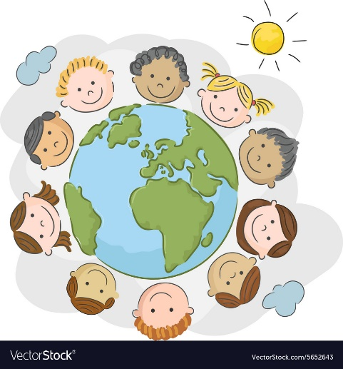 | History: How have the clothes that we wear changed over time and why?  We will find out how spinning and weaving have developed over time. We will practice using a drop spindle, master the basics of weaving and produce a piece of cloth using a cardboard loom. We will learn about key developments in weaving technology from its beginnings as a medieval cottage industry and see how developments in the textile industry affected Britain in the 18th and 19th centuries.  Art  This term we will find out about Tanzanian painter Edward Saidi Tingatinga (1932–1972) who created beautiful and vibrant pieces of art featuring animals, birds and folk stories.  RE  We are looking into festivals that are important to religious communities such as Muslims and Jews.  French  Every Tuesday with our teacher who comes from France  Music  We have music with Trafford Music Service on Thursday.  PE  On Wednesdays with Mr Richie.
SPECIAL EVENTS/HOLIDAYS   | Please keep up-to-date with letters and our web page where you find all our special events organised!  - Please refer to our school calendar 2021-2022 – reminders to follow as and when they occur.
READING  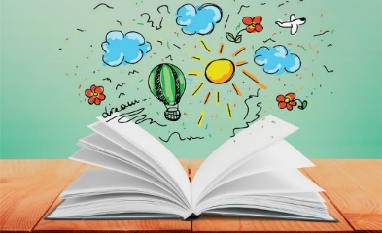 | We read every day in school and if possible, we would like you to read with your child each night.
INDIVIDUAL BEHAVIOUR TARGETS
Please refer to your child’s IBP and get in touch with the class teacher if you have any concerns.

