
Class Plan
Class: Henigan Term: Summer 2022
SUBJECT | LEARNING
LITERACY  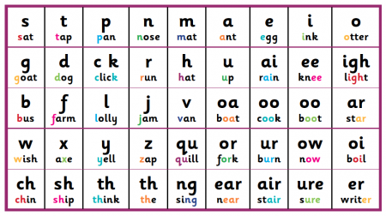 | - Phonics: Letters and Sounds.  - Handwriting: pencil grip and letter formation.  - Reading a range of fiction and non-fiction texts for pleasure
MATHS  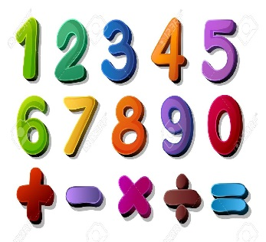 | Summer 1  Reception:  -Using numbers to 10 in context.  -Adding and subtracting one digit numbers using objects and formal methods.  Year 1 and 2:  -Counting to 50.  -Recognising tens and ones for numbers to 50.  -Length and height.  -Measuring in CM and using topic related vocabulary.  -Comparing different measurements for length and height.
SCIENCE  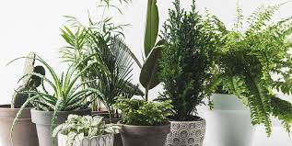 | Year 1 - Plants  Explore different types of fruit and how they are grown.  Identify and describe the functions of different parts of flowering plants: roots, stem/trunk, leaves and flowers.  Explore the requirements of plants for life and growth (air, light, water, nutrients from soil, and room to grow).  Observe over time how much a plant grows.  Explore and discuss the function of pollen and pollination for plants.
Geography   | Topic: Locational/place knowledge- What is it like in the jungle?  Pupils should develop knowledge about the world. They should understand basic subject-specific vocabulary relating to human and physical geography to enhance their locational awareness.  Locational Knowledge  name and locate one of the world’s seven continents  Place knowledge  ▪ understand geographical similarities and differences through studying the human and physical geography of a small area of the United Kingdom, and of a small area in a contrasting non-European country  Human and physical geography  use basic geographical vocabulary to refer to  key physical features,  key human features,  Geographical skills and fieldwork  ▪ use world maps, atlases and globes to identify the countries, continents and oceans studied  Art – Sara Sherwood.  Exploring and Developing Ideas, Work of Artists, Drawing lines using different materials/thickness,  Painting experimenting with different brushstrokes/tools & primary/secondary colours  RE – Where do we belong?  Music - Trafford Music Service on Tuesdays.  PE – taught by Mr Ritchie on Monday – Please have your PE kit.
SPECIAL EVENTS/HOLIDAYS   | Please keep up-to-date with letters and our web page where you find all our special events organised!  - Please refer to our school calendar 2021-2022 – reminders to follow as and when they occur.  Please keep your eye on Class Dojo for class and school information. If you need to contact me please do via Dojo or call the school.
READING   | We read every day in school and if possible, we would like you to read with your child each night. Please record this in your child’s reading record.

