
Class Plans
Class: Pogson Term: Summer 1 2022

SUBJECT | LEARNING
English – Diaries and Recounts  Through The Day I Swapped my Dad for Two Goldfish and The Diary of a Killer Cat,  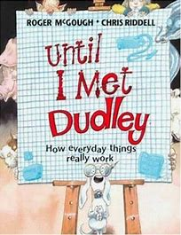 | - Explore and write recounts  - Orally present an explanation text.  - Study adverbs for time and place. Invent a new technology  - Study direct speech
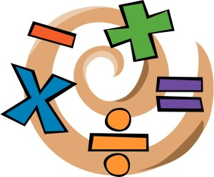  NUMERACY | - Fractions  - Decimals
SCIENCE – Electricity (Year 4) | Year 4  - identify common appliances that run on electricity  - construct a simple series electrical circuit, identifying and naming its basic parts, including cells, wires, bulbs, switches and buzzers  - identify whether or not a lamp will light in a simple series circuit, based on whether or not the lamp is part of a complete loop with a battery  - recognise that a switch opens and closes a circuit and associate this with whether or not a lamp lights in a simple series circuit  - recognise some common conductors and insulators, and associate metals with being good conductors
History – Ancient Egypt  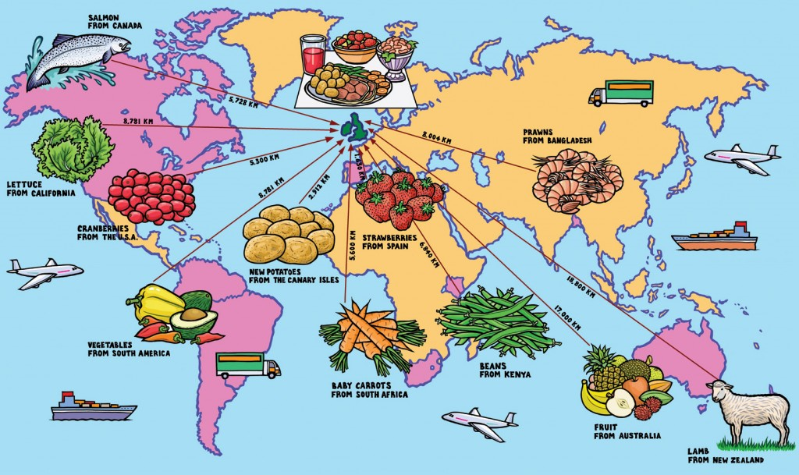 | - What I already know about ancient Egypt  - Where is Egypt? The Nile?  - What is mummification? What is the afterlife?  - Famous Pharaohs: who were they and what was their life like  - Egyptian gods
Other curriculum areas | PSHE – Physical and mental health  R.E – Why do some people think that life is like a journey and what significant experience mark this?  P.E – weekly session with Mr Ritchie  Music – Weekly session with Beth
HOMEWORK PRIORITIES | - Reading nightly  - TT Rockstars (10-15 mins)

