SUBJECT | LEARNING
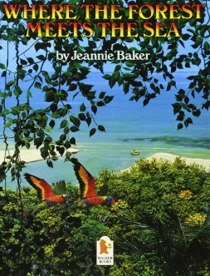  English | - Where the forest meets the sea by Jeannie Baker  - Identifying the features of persuasive writing  - Recognising fact and opinion  - Researching for facts about the rainforest  - Planning a persuasive piece of writing to save the rainforest  - Writing out own persuasive texts to save the rainforest  - Expanded noun phrases and preposition phrases.  - Weekly spelling/grammar activities  - Class novel: How to train your dragon by Cressida Cowell
Maths | Group 1:  - Equivalent fractions  - Comparing & ordering  - Finding fractions of amounts  - Adding & subtracting fractions  - Parallel/perpendicular lines  - Measure and compare measure  - Times tables practice | Group 2:  - Comparing & ordering  - Mixed number & improper fractions  - Finding fractions of amounts  - Multiplying fractions  - Perimeter & area  - Volume
Science | - Animals including humans.  - Digestive system  - Teeth  - Aging and human development  - Circulatory system
Topic | - Geography: Out of Africa  - Using maps and atlases to locate various countries within Africa.  - The similarities and differences between African countries.  - Physical features, including climate zones  - Human geography, including distribution of natural resources
Other Curriculum Areas | - Computing: E-safety & programming, including different devices  - RE: Forgiveness  - PSHE: Independence, managing risk and solving problems  - PE with Mr Ritchie: Gymnastics  - Music with Beth: composing and writing music  - DT: Electric ‘buzzer’ games
Priorities | - Daily reading (or online BugClub)  - Please ensure your child has a coat, bag and water bottle every day.  - PE kit & trainers needed every Tuesday.
Special Events | All events this term are dependent on COVID restrictions.  Please check letters sent home and Class Dojo regularly for any updates.

Please also see your child’s IEP for their personalised targets relating to their EHCP.

