

Welcome to
Class Harvey
Welcome to Class Harvey
Dear Parents and Carers,
Class Harvey staff are Miss Harvey and Mr Cooke and we would like to welcome you to our wonderful class. I feel it is important to share some key information with yourselves on day to day practices and other information that you may require.
PE
Children are required to bring their PE kit (shorts, t shirt and pumps) and leave it in school. PE lessons will take place on Tuesday and Wednesday although there may be other times during the week when they may require their kit in school. Please ensure that all items are clearly labelled and help us to encourage your child to take responsibility for their kit.

Dropping off and collecting your child from school
The school day begins at 9am. All pupils enter the school by the rear door (if on buses) or front (if dropped off).

Pupils finish at 3:00pm each day.
Many pupils travel to and from home by taxi or mini bus provided by Trafford Transport.

If you are collecting your child please go to the front of the school where your child will be brought to you by a member of staff.

If somebody different is collecting your child from school, please inform school. If the teacher does not know the person collecting your child and has not received a letter, they will not allow your child to leave with them.

A typical day at school…

9.00am | Back/Front doors open and children go straight in to their classes
9.00am - 10.30am | Session 1
10.30am – 11.00am | Morning playtime
11.00am – 12.00noon | Session 2
12.00pm – 1.00pm | Lunchtime class staff sit with children
1.00pm – 2.00pm | Session 3
2.00pm – 3.00pm | Session 4
3.00pm | End of the day

r Timetable

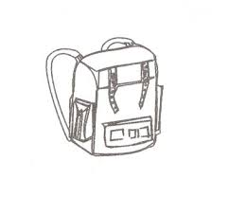Each child should bring a bag to school each day for reading books as well as letters and messages. If they do not have one they are available to buy from the school office. Any letters or reply slips, which need to be returned, can be put in your child’s book bag. The children are encouraged to check them each morning and give things in after the register.
Any money needs to be in a clearly labelled an envelope and given in to the office or to myself at registration.

OUR REWARD SYSTEMS
As stated in the Relationship Policy pupils earn points during each session, and where appropriate will be given warnings before a point is deducted for displaying inappropriate behaviour.
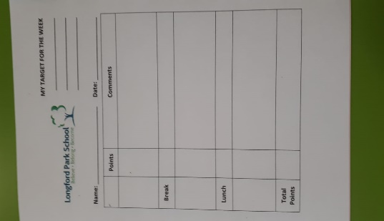
Each child starts the lesson on 5 points as a target. If all work is completed, and the child remains focused in class with no disruptions, they will complete the session with all 5 points. If any violence, aggression, disruptive behaviours or inappropriate language is used, points will be deducted for that session. Children should aim to achieve 25 points by the end of the day.

In class, we also have our own incentive chosen by the children in class. Each child is on Class Dojo – here, the children are able to earn dojos to trade in for prizes on a Friday afternoon. The children can either buy little, weekly prizes, or save them up to take away one of the more substantial prizes. This is their personal choice.



Scores per session:
5 - Outstanding
4 – Great
3 – Well Done
2 – Room For Improvement
1 – Turn It Around
An example of a pupil daily target sheet.

:

The terms are always a busy so please refer to the Calendar on the website, and be on the lookout for letters informing you of events taking place. Information is posted on the website as well letters being sent home.
There are also two school information boards on the school premises; one at the front near the entrance and one at the rear of the school, near the pick-up point for parents
Uniform
Please can your child ensure they arrive at school in full school uniform and suitable, black shoes are worn. Children may bring trainers to change into for breaktimes if preferred.


Homework
On Fridays, I will be setting reading tasks for the children to complete using Collins Ebook. All logins will be sent home for your personal use but please do let me know, if you have any trouble accessing this.
Please spend time with your child introducing them to as many social gatherings/activities as possible. We encourage children to spend time learning through experiences opposed to direct homework.

We are confident that your child will have a happy, productive term but should you wish to discuss any aspects of their experiences at Longford Park School, please do not hesitate to phone and discuss them with us or make an appointment through the School Office.
Many thanks for your continued support. We look forward to working with you throughout the year.
Miss Harvey

Parent Coffee mornings 

The Parent Coffee mornings are an opportunity for parents to get together and chat over coffee. It meets half termly and is a discussion forum without members of staff. Everyone is welcome!

LPS Parent Partnership


We meet termly to discuss ways forward to improve and enhance the communications between home and school. It is not a mechanism for dealing with complaints of any description but will discuss/debate general issues that affect the welfare and safety of all children.

