
Class Plans
Class: Shafai Term: Spring 1 2022
SUBJECT | LEARNING
LITERACY  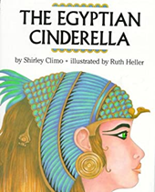 | This term our focus book will be Egyptian Cinderella. It is a book based on the traditional story of Cinderella but set in Ancient Egypt and with an Egyptian twist. It will tie in with our history topic on ancient Egypt.  We will also be concentrating on our punctuation and grammar and making our writing very interesting by using lots of adjectives, nouns, verbs and looking into speech marks.
MATHEMATICS  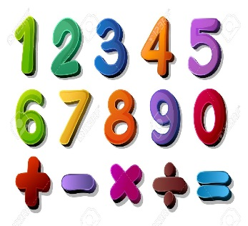 | Spring one Year Two  Multiplication and division  Money | Spring one Year Three  Multiplication and Division  Measurement
SCIENCE  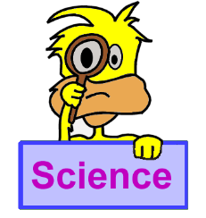 | For our Year Three science will this be looking at rocks, comparing different types of rocks and looking at fossils  For our Year Four science we will be looking at electricity, why electricity is important and how we create electricity | We will all think about our topics and come up with enquiry questions and find out the answers to our questions!
OTHER TOPICS    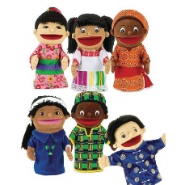 | Topic: in our topic work this term to are going back in time to Ancient Egypt.  Design Technology  This term we will be focussing on cooking.  RE – We are looking into Judaism.  Music - with Trafford Music Service on Thursdays  PE – with Mr Ritchie on Wednesdays.
SPECIAL EVENTS/HOLIDAYS   | Please keep up-to-date with letters and our web page where you find all our special events organised!  - Please refer to our school calendar 2021-2022 – reminders to follow as and when they occur.
READING  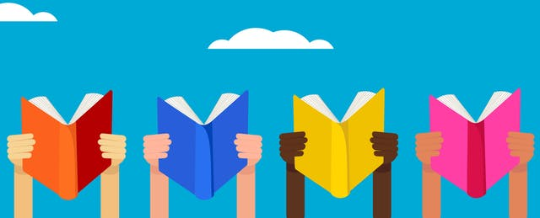 | We read every day in school and if possible, we would like you to read with your child each night.

INDIVIDUAL BEHAVIOUR TARGETS
Please refer to your child’s IBP and get in touch with the class teacher if you have any concerns.
...................................................................................................................................................

