CLASS Broomhead January 2022- February 2022

SUBJECT | LEARNING
English – Non-Fiction – Extraordinary Animal Biogrophies   | - Identify the main features of a biographical text  - Explore paragraphs and headings  - Using time language  - Adverbials  - Writing biographies  - Editing and improving writing
  NUMERACY | - Multiplication  - Times tables  - Factors  - Division  - Shape and Angles
SCIENCE – Sound (group 1)  Everyday Objects (group 2)  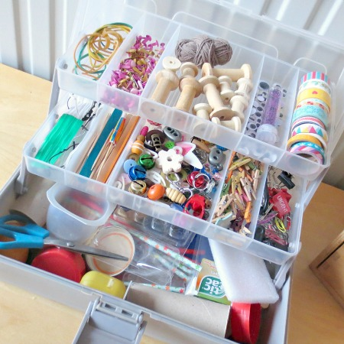 | Group 1  - identify how sounds are made, associating some of them with something vibrating  - recognise that vibrations from sounds travel through a medium to the ear  - find patterns between the pitch of a sound and features of the object that produced it  - find patterns between the volume of a sound and the strength of the vibrations that produced it  - recognise that sounds get fainter as the distance from the sound source increases | Group 2  - identify and compare the suitability of a variety of everyday materials, including wood, metal, plastic, glass, brick, rock, paper and cardboard for particular uses  - find out how the shapes of solid objects made from some materials can be changed by squashing, bending, twisting and stretching
Geography – Biomes and climate change  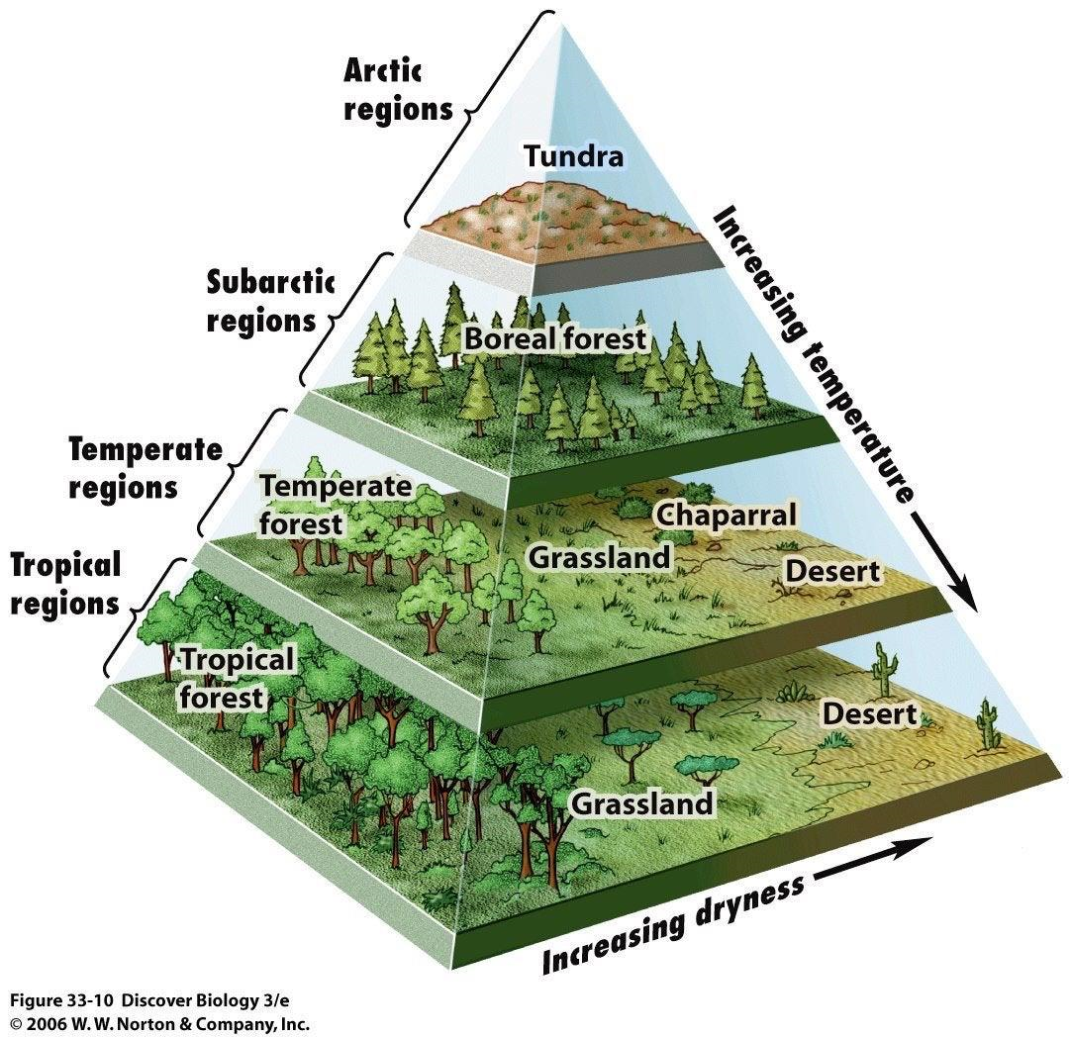 | - Understand the different biomes that make up our planet  - Create a biome in a bag  - Research environmental problems and solutions  - Create a miniature Eden Project with their chosen biome  - Create a guide to their biome with an emphasis on conservation issues
Other curriculum areas | Computing – Programming  Art – Henry Moore sculpture  PSHE – Disability awareness  R.E – Islamic and Jewish Festivals  P.E – weekly session with Mr Ritchie  Music – Weekly session with Beth
HOMEWORK PRIORITIES | - Reading nightly  - Bug Club  - TT Rockstars (10-15 mins)

