
Class Plans
Class: Shafai Term: Autumn one 2021
SUBJECT | LEARNING
LITERACY  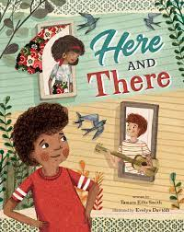 | This term our focus book will be the Here and There. It is a book about a boy who mum lives in one house and his dad lives in a different house and explores the themes around this.  We will also be concentrating on our punctuation and grammar and making our writing very interesting by using lots of adjectives, nouns, verbs and similes.
MATHEMATICS  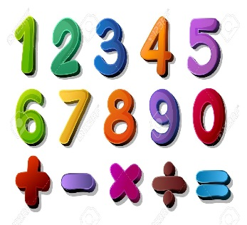 | Autumn One Year Two  Place Value  Addition and subtraction | Autumn One Year Three  Place Value  Addition and subtraction
SCIENCE  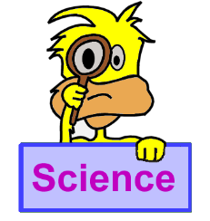 | Year Three- Forces and Magnets  We will be looking at forces and magnets in depth and learning lots of new science words that relate to this topic | We will all think about our topic and come up with enquiry questions and find out the answers to our questions!
OTHER TOPICS    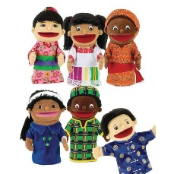 | Topic: How the Tudors changed England! This term we will be looking at the Tudors and how England changed under them with amazing inventions, plays and poems.  Design Technology  This term we will be focussing on making our own puppets.  RE – We are looking into Islam  Music - with Trafford Music Service on Thursday.  PE – with Mr Ritchie on Wednesdays.
SPECIAL EVENTS/HOLIDAYS   | Please keep up-to-date with letters and our web page where you find all our special events organised!  - Please refer to our school calendar 2021-2022 – reminders to follow as and when they occur.
READING   | We read every day in school and if possible, we would like you to read with your child each night.

INDIVIDUAL BEHAVIOUR TARGETS
Please refer to your child’s IBP and get in touch with the class teacher if you have any concerns.

