Class Plans Mrs Nealon Autumn 1 2021 2022
SUBJECT | LEARNING
LITERACY   | 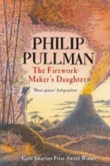  Written Outcomes: Retell one significant event from Lila’s point of view, her journey up the mountain and meeting fire god. Information text – Rocks/soils  Information text on volcanoes  Poetry – List poems on fireworks
MATHEMATICS  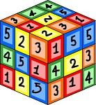 | - Addition and Subtraction  - Multiplication and Division  - Place Value
SCIENCE  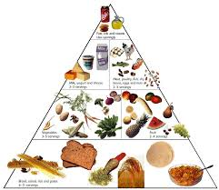 | - Understand that plants and animals obtain food in different ways.  - Identify the right types and demonstrate they understand the right amounts of nutrients for animals including humans.  - Name the different types of skeletons as well as identify and categorise animals based on the type of skeleton it has.  - Identify the main bones in the body and how a skeleton protects, supports and helps the body to move.  - Explain how pairs of muscles work together to enable movement.
TOPIC  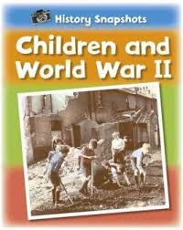 | What Impact did World War II have on life in Briatin?  • know when the war started and tell you some of the  countries and key individuals involved;  • recall basic details about key events and know that  the Battle of Britain was a turning point in the war;  • describe some things people on the home front did to  support the war effort;  • list examples of things people did for entertainment  during the war;  • tell you some wartime events that are commemorated  each year
SPECIAL EVENTS
HOMEWORK | - Bug Club, Daily - Reading  - Learn your times tables

INDIVIDUAL BEHAVIOUR TARGETS: Remember to put up your hands and concentrate fully.
LEARNING TARGETS: Learn your tables.
Play to Learn Monday PE Wednesday

