
Class Plan
Class: Bonsall/Henigan Term: Autumn one 2021
Subject: | Learning:
Maths  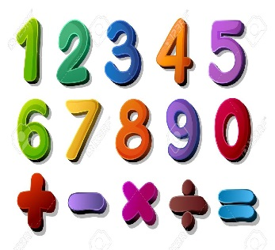 | -Pace value  - Number bonds to 10 and 20
English:  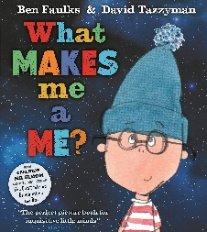 | This term the book we will be focusing on I “What makes me a me” By Ben Faulks. The book is about a little boy who is about what makes him, him. He goes on a journey and talks about his life and what he is like.  We will be focusing on letter formations and sequencing the book through different activities.
Science  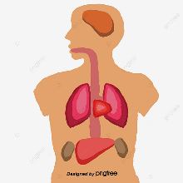 | Humans:  -How the body grow and changes over time.  -The similarities and differences in our bodies.  -The different body parts and their function.  -Resting heart rate.
Geography   | Topic: Where do I Live?  - Our classroom  - Our school  - Where we live  - Our surround buildings.
Other topics:   | Art – Kandinsky:  Exploring and Developing Ideas, drawing, college making and painting.  RE – Which people are special and why?  Music - Trafford Music Service on Fridays.  Computing – E Safety  PE – taught by Mr Ritchie on a Monday.
SPECIAL EVENTS/HOLIDAYS   | Please keep up-to-date with letters and our web page where you find all our special events organised!  - Please refer to our school calendar 2021-2022 – reminders to follow as and when they occur.
READING  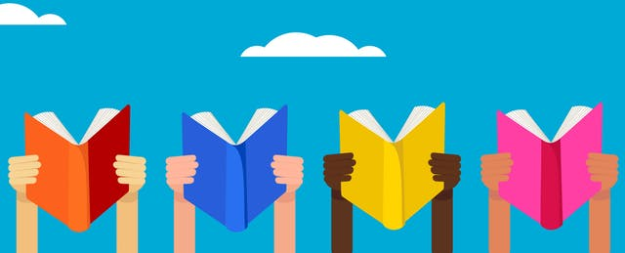 | We read every day in school.  Your child will taking a reading book home to read with an adult. Please try and read a few pages with your child and record it in their reading record.

