
Class Plan
Class: Lamb Term: Autumn 1 2021
SUBJECT | LEARNING
LITERACY  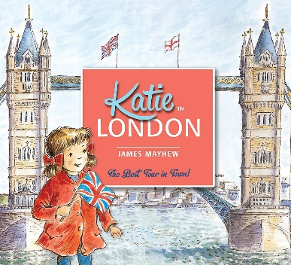 | This term we will be reading Katie in London by James Mayhew.  This book is linked to our topic about the world around us.  We will be:  Writing setting descriptions  Writing information texts about London  Using connectives to join our sentences  Punctuation – Capital letters, full stops, finger spaces, question marks, commas in lists.
MATHS  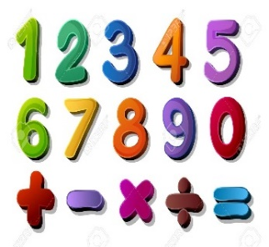 | Autumn Year 2  Place Value – numbers to 100  Addition and Subtraction | Autumn Year Three  Place value – numbers to 1000  Addition and Subtraction
SCIENCE  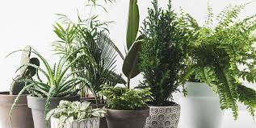 | Year 2  Identify and describe the basic structure of a variety of common flowering plants, including trees.  Observe and describe how seeds and bulbs grow into mature plants.  Find out and describe how plants need water, light and a suitable temperature to grow and stay healthy.
GEOGRAPHY   | Topic: You’re Great Britain!  We will be learning about the world around us.  - Using world maps, atlases and globes to identify the United Kingdom and its countries as well as countries, continents and oceans.  - Use simple compass directions (N, S, E and W)  - Use aerial photographs to recognise landmarks and basic human and physical features.    - Create our own maps.  Art – Yayoi Kusama  Exploring and Developing Ideas, Work of Artists  Printing copying an original print by making own simple print blocks (eg by cutting veg/pieces of card),  Sculpture cutting/combining shapes to make recognisable forms using clay.  RE – Who is a Christian and what do they believe?  Music - Trafford Music Service on Fridays.  Computing – E Safety  PE – taught by Mr Ritchie on a Monday.
SPECIAL EVENTS/HOLIDAYS   | Please keep up-to-date with letters and our web page where you find all our special events organised!  - Please refer to our school calendar 2021-2022 – reminders to follow as and when they occur.
READING   | We read every day in school.  Your child will taking a reading book home to read with an adult. Please try and read a few pages with your child and record it in their reading record.

